SnowBird

2018-10-30

Raymond Knorr, Ali Rizvi,

Priscilla Chua, Zain Abedin,

Li Pan, Sana Khan

Intranet Content Strategy Proposal

Our underlying idea behind the content on the intranet system is that each sub-faculty of engineering would have their own private sight. This sight would would only show the member of that faculty the content that is immediately important to them. However, in less common cases, the user may want to see some content that belongs to a different faculty. This would also be allowable, but slightly more intensive to navigate to. For example, if a software faculty member was trying to view a form that was normally used by industrial lab professors, then the software faculty member would be able to expand their list of forms to include all possible viewable forms, which would include the industrial lab forms. This expandable list would of course only include forms that do not violate any security measures.

Our first idea of a content structure was to have five main headings: Forms, Committee’s, Course Materials, Research Areas, and Documentation. As each of these are included in some way into the final proposal, they will be discussed in-depth in a later section. This tree was relatively wide, and very shallow, so we decided to lump the Forms and Documentation together into one main heading. A diagram of our first tree is included below:

Figure 1: Initial Content Structure Proposal

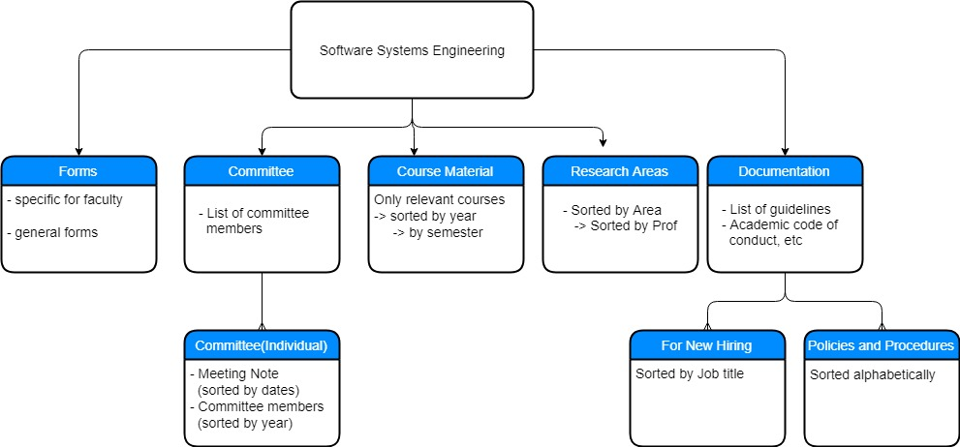

After merging the forms and documents into one main heading, our final design had headings consisting of Committees, Course Material, Research Areas, and Forms/Documentation. Our choice of design could end up being pretty resource-intensive, especially on initial set-up, as each faculty would require a subset of the contents of a full engineering site. However, if this initial investment is made, the majority of regular users would likely have a much more efficient workflow. A diagram of this final tree is given below:

Figure 2: Final Content Structure Proposal

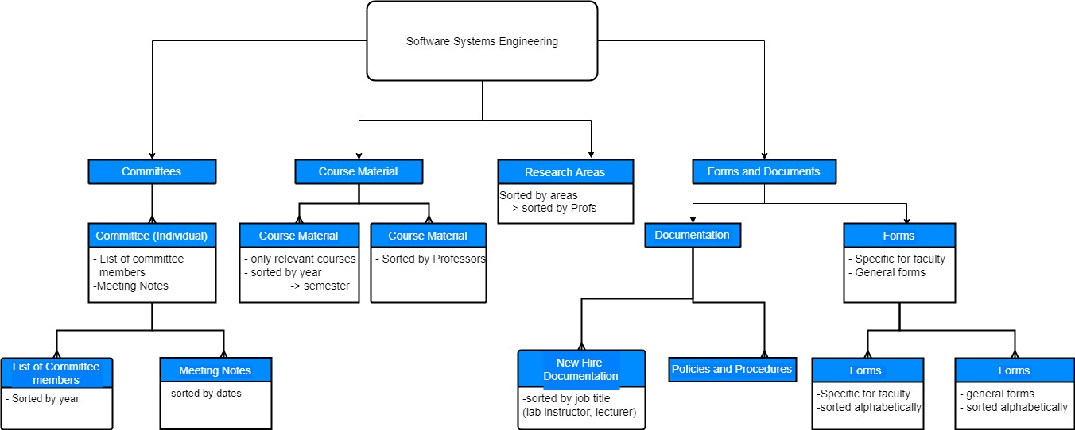

An overview of the tree by section follows:

The Committee section will contain a list of all committees that are relevant to the faculty. After the user selects a committee, they will have the option to view either a list of meeting notes sorted by the date of the meeting, or a list of the committee’s members sorted by the year that they were on the committee.

The Course Material section will provide the user with the option to view the courses in that faculty. There will be two possible ways that the courses are sorted: by the course number, then the year and semester that the course is offered, or by the professor that is teaching the course.

Research Areas will simply contain a list of areas grouped by similarity. Within these sections, the research areas will be sectioned based on the professor that is doing the research. Again, by default, only the research areas that are most pertinent to the page’s faculty will be shown. Following our main design listed above, a link to a full list would also be available.

Forms and Documentation will encompass all of the paperwork on the site. As its name implies, it will be separated into a section for purely Forms and a section for Documentation. Documentation will include two separate subfolders: New Hire Documentation, which will detail expectations and general info for a newly hired employee (sorted by job title), and Policy and Procedures, which would include documents relating to Co-op instructions, lab policy, safety resources, academic misconduct, etc.. The Forms subsection would also be split into two parts: Faculty Specific Forms, that focus on the users faculty (such as event registration forms for only software students), and General Forms, which would be usable by all engineering site users (such as certain application forms, payroll form, laboratory & key card access forms, travel-related forms, etc.). As a side note, forms were the main content that we proposed for removal from the public site.

Two other aspects of an effective content strategy are workflow and security/privacy. In terms of workflow, the navigation tree of our site is only three generations deep, with a main nav bar allowing easy access to the first level. This means that an average user would have a theoretical maximum of three clicks to reach anywhere else on the site, allowing for a relatively easy workflow. The idea of separating the site by sub-faculty aims to add a level of privacy at this level, where content will only be viewable by people in that faculty. If more security is needed, there could be some sort of permissions system added where individual users could have access to special pages, but we do not know at this point how this would fit in with the production of the private sites.